Unit 2 Test Prep
- What is the factored form for this equation. $y= {6x}^{2}+ 19x - 7$

- What is the general form for the equation $f\left(x\right)=-5{\left(x+2\right)}^{2}-4$

f(x) =

- Complete the square to write the quadratic function in standard form.
$$f\left(x\right)={5x}^{2}-30x+6$$

f(x) =

- Complete the square to write the quadratic in standard form

f(x) =
- Use the graph to answer the following questions.

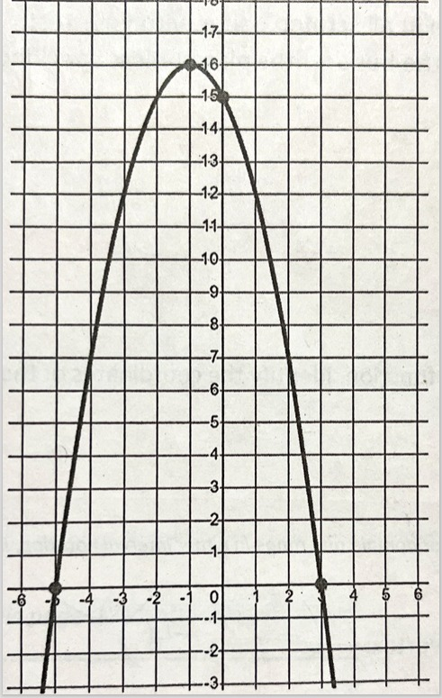

Is the leading coefficient (a) a positive or negative?
Positive Negative

Vertex:

Axis of Symmetry:

Coordinates of the x-intercept(s):

Coordinates of the y-intercept(s):

- Use the graph to write the quadratic function in standard form.
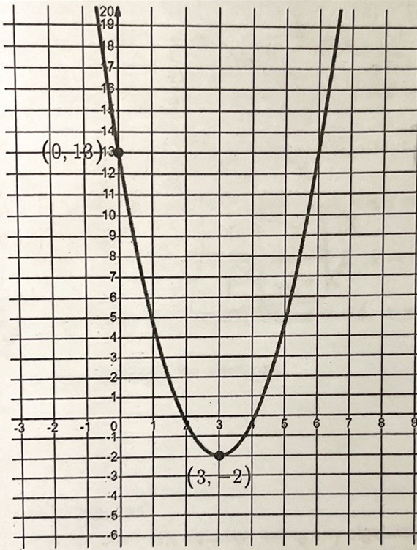

f(x) =

- The graph of the function f(x) is shown. Use the graph to solve the equation f(x) = 0.
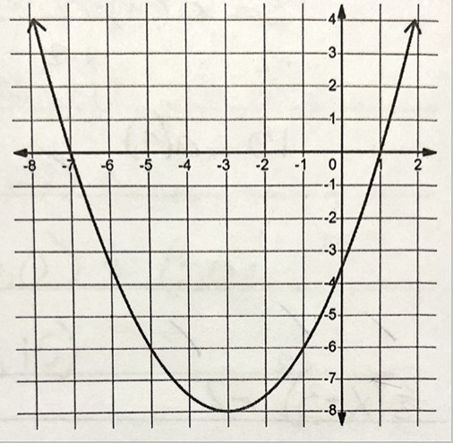
- X = -3, X = 8

- X = 0

- X = 0, X = -4

- X = -7, X = 1

- X = -8, X = 2

- The vertex is (0, -4) and passes through the point (-1, -3). What is the formula?

- A model rocket is shot straight upward with an initial speed of 800 ft/s, and the height of the rocket is given by h(t) = $800t - {16t}^{2}$, where his measured in feet and t in seconds.

- How many seconds does it take for the rocket to reach a height of 8000 feet?

- How long does it take for the rocket to hit the ground?

- What is the maximum height of the rocket, and after how many seconds is this height reached?

- If the parent function is f(x) = $x^{2}$, what are the transformations for the following equation. $g(x) = -2{(x-3)}^{2}- 4$

- If the parent function is f(x) = $\log_{2}{x}$, what are the transformations f(x)= $\frac{3}{5}\log_{2}{(x+8)+5}$

